Hansonlóság

10. tk 2. kötet 106 + oldal

Középpontos hasonlóság:
- kell egy középpont (általában O aka.Origó)
- Hasonlóság arnánya (K)
- P’ = P-O*K
  - ha k > 1 => nagyítás
  - ha k < 1 => kicsinítés
  - ha k = 1 => egybevágóság
- a₁ = k*a
- k = a₁/a=b₁/b=c₁/c
- hasonló síkidomok kerületeinek aránya megegyezik a hasonlóság arányával

1. 113 tk 1. kidolgozott feladat

a₁=5cm
b₁=7cm
k=3
a₂=k*a₁
b₂=k*b₁
K₁=2*5+2*7=24cm
K₂=2*15+2*21=72cm K₂/K₁=72/24=3=k
T₁=5*7=35cm²
T₂=15*21=315cm² T₁/T₂=315/35=9=3²=k²

2. 114/1
háromszög: 12cm; 15cm; 16cm
a₁ b₁ c₁
b₂=10cm
k=10/15=2/3
a₂=k*a₁=2/3*12=8
c₂=k*b₁=2/3*16=10.666

hf 114/2
a K₂=16dm
a₁=10cm a₂=a₁*k=50cm
b₁=10cm b₂=b₁*k=50cm
c₁=12cm c₂=c₁*k=60cm
K1=32cm 3.2dm
k=K2/K1=16/3.2=5

b T₃=12cm²
m²=a₁²-c₁²/2=100-36=64
m=8

T₁=(12*8)/2=48cm²
k²=T₃/T₁=12/48=.25
k=.5
a₃=k*a₁=.5*10=5cm
b₃=k*b₁=.5*10=5cm
c₃=k*c₁=.5*12=6cm
T₃=6*4/2=12cm²


hf 125/2


a ADC – BDC
b AFC – BAE
c ADE – ABC

125/3


a ABC – ACQ – APD
b, c
- AB – 8cm
- DC – 8cm
- AD – 10cm
- BC – 10cm
- PC – 2cm
- PD – 6cm
- CQ – 10/3cm
- AQ – 11.66cm
- PQ – 3.89cm

hf 125/2 piros



Trigonometria

2 hasonló háromszög

k = a’/a=b’/b=c’/c

a’/a=b’/b /reciprok
a/a’ = b/b’ / *a’; /b
a/b=a’/b’

Definióció tg alpha = a/b

11. tk 7 oldal

tg 30°=0.5774
tg 45°=1
tg 90°=error
tg 60°=1.7321

7/4:
1
aplha = 0.6333
beta = 1.5789

2
m = 4cm
gamma= atan(m/3) = atan(1.3333) = 53.1232

7/5:

alpha=atan(0.75)=36.8699
beta = 180-(alpha+gamma)=53.1301
gamma= 90
a= 12cm
b= 16cm
c= 20cm
m=9.6cm
p=12.8cm

q=7.2cm

13/3:

alpha = .2588
c = 500 m
a = 129.4 m
b= 482.9655 m
b feladat =
.2588= a/500= 129.4


13/5

c=14cm
alpha=22°
cos(alpha)=0.9271
b= 12.9806cm
a/2=5.2445cm
a=10.4890cm

hf 13/1 (piros)
a= 0.5m
b=2m
alpha=atan(a/b)=atan(0.25)=14.0362°


1.
2*sin(30)+3*cos(60)+tan(45)=x
2*1/2+3*1/2+1=x
3.5(7/2)=x

2.
(tan(45))²-(sin(30))²-(cos(60))²=x
1²-(1/2)²-(1/2)²=x
1-1/4-1/4=x
1/2=x

3.
(2-tan(45))/(sin(45)*cos(45))=x
(2-1)/((sqrt(2)/2)*(sqrt(2)/2)=x
1/(2/4)=x
2=x

hf 14 elmélet olvasása

tan(alpha)=(sin(alpha)/cos(alpha))
sin²(alpha)+cos²(alpha)=1


15/4(barna)
sin(alpha)=0.8
cos(alpha)=?
tan(alpha)=?
sin²(alpha)+cos²(alpha)=1
(0.8)²+cos²(alpha)=1
0.64+cos²(alpha)=1
cos²(alpha)=0.36
cos(alpha)=0.6

15/3

alpha=35°
h=?
sin(alpha)=h/k
sin(35)=h/80
h=80*sin(35)=45.886
b.
k=50m
alpha=58
h=?
sin(58)=h/50
h=50*sin(58)=42,402m



hf 15/1,3,4 (piros)
1
a=50m
c=95m
alpha=?
Alpha =asin(a/c)=asin(50/95) =31.7569°

3
alpha = 70°
m=?=1.6+x=1.6+(8*tan(70)) =23.5798

4
b=20
a=0.4
alpha=atan(a/b)=atan(0.4/20)= 1.1458°

tan(alpha)=sin(alpha)/cos(alpha)
sin²(alpha)+cos²(alpha)=1
sin(alpha)=cos(90°-alpha)
cos(alpha)=sin(90-alpha)

16/1 kidollgozott


alpha=?=90-gamma=90-acos(10.8/12)=90-25.8419=64.1581
Beta=?=180-2alpha=180-2*64.1581=51.6838

17/1


a:1 (jobb felső), 2 (bal alsó)
b:2 (bal alsó),3 (jobb alsó), 4 (felső), 5 (bal alsó nem jelölt)

hf 18/1, 3 piros

a=712
c=435
beta = 6° depresszió

doga kidolgozás:

t=s/c
s2+c2=1
s=c(90-)
c=s(90-)s=c(90-)
s c t
30 1/2 sqrt(3)/2 sqrt(3)/3
45 sqrt(2)/2 sqrt(2)/2 1
60 sqrt(3)/2 1/2 sqrt(3)
° a/c b/c a/b

Új területképlet:
20.oldal
paralelogramma magassága:
sin(gamma)=magasság/b
T=a*b*sin(gamma)

általános háromszög
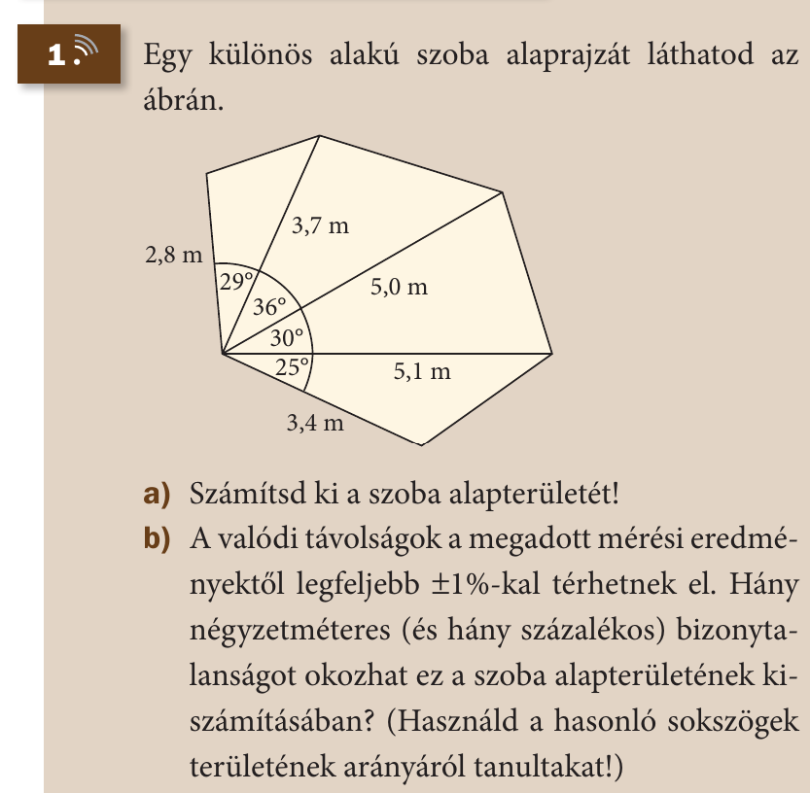
T=(a*m)/2
T=(a*b*sin(gamma))/2

21/1 (barna)
T=T₁+T₂+T₃+T₄=17.9864cm²
T₁=2.8*3.7*sin(29)/2=2.5113
T₂=3.7*5*sin(36)/2=5.4370
T₃=5*5.1*sin(30)/2=6.375
T₄=5.1*3.4*sin(25)/2=3.6641
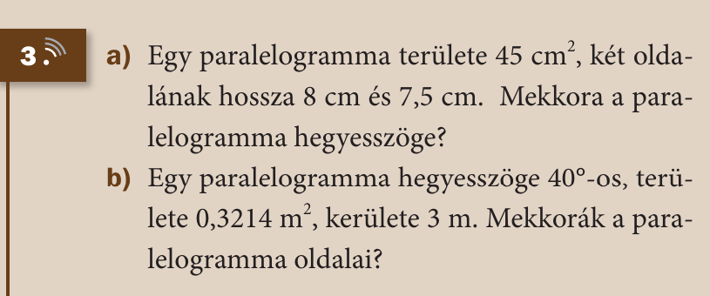
21/3 (barna)
T=45cm²
a=8cm
b=7.5cm
gamma=?
T=a*b*sin(gamma)
45=8*7.5*sin(gamma)
sin(gamma)=0.75
gamma=48.5904°

alpha = 40°
T=0.3214m²=a*b*sin(alpha)
K=3m=2*(a+b)
a=?
b=?

0.3214=a*b*sin(alpha)
a*b=0.3214/sin(alpha)
a*b=0.5

3=2*(a+b)
a+b=3/2=1.5

a*b=0.5
a+b=1.5=a=1.5.-b
(1.5-b)*b=0.5
1.5b-b²=0.5
-b²+1.5b-0.5=0
-2b²+3b-1=0

(-3+-sqrt(9-8))/(-4)
(-3+-1)=(-4)
b₁=0.5
b₂=1

a₁=1.5-0.5=1
a₂=1.5-1=0.5
Mo: (1;0.5) és (0.5;1)

hf befejezni+ 21/1,3 (piros)

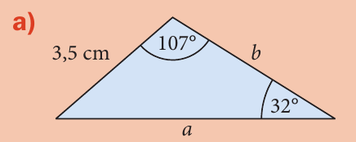
27/1 (piros)
a = ? = c*sin(alpha)/sin(gamma) = 3.5*sin(107)*sin(32) = 6.3162cm
b = ? = c*sin(beta)/sin(gamma) = 3.5*(sin(40)/sin(32)) = 4.2455cm
c = 3.5cm
alpha = 107°
beta = 40°
gamma = 32°
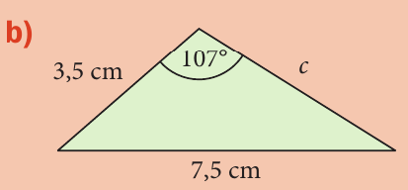
a = 3.5cm
b = 7.5cm
c = ? = sin(gamma)/sin(beta)*b = sin(46.495)/sin(107)*7.5 = 5.6884
alpha = ? = asin(a/b*sin(beta)) = asin(3.5/7.5*sin(107)) = 26.5050°
Beta = 107°
gamma = ? = 180-(alpha+beta) = 180-(26.5050+107) = 46.495°

hf 27/3,4 (barna)

Tk 33/2

cos(alpha)=0.5
cos(beta)=0
alpha=60°
beta=90°
gamma=30°
sin(30)=0.5
cos(30)=0.866

Hf 33/2 (barna)
b
cos(alpha)=sqrt(3)/2
sin(gamma)=?
cos(beta)=-0.5
cos(gamma)=?
3.
cos(alpha)=?
sin(alpha)=sqrt(2)/2
sin(alpha)=0.7357

koszinusztétel
c²=a²+b²-2ab*cos(gamma)
a²=c²+b²-2cb*cos(alpha)
b²=a²+c²-2ac*cos(beta)

35/1
c²=53²+71²-2*53*71*cos(60)
c²=4087
c=63.93

gamma=147

c²=53²+71²-2*53*71*cos(147)
c²=14161.83
c=119

35/2

